School is Cool for Everyone

A puppet-based DVD aimed at improving primary school attendance.

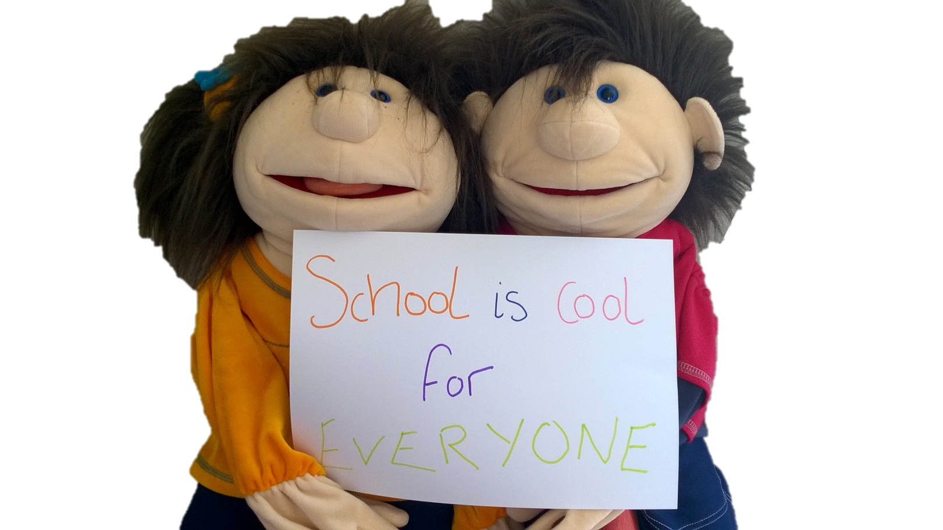
Introduction

‘School is Cool for Everyone’ is a puppet-based DVD developed by the Education Welfare Service in conjunction with BEAM Creative Network.

Target Group: P1 – P4 Pupils and their parents/guardians, particularly those who present as low attenders.

Objectives: Help children understand the importance of being in school.
Make children aware of the negative effects of missing days in school.
Help children differentiate between valid and invalid reasons for missing schools.
Present school life in a very positive light.
Challenge parent/guardian views on attendance.

Overall aim: It is hoped that the ‘School is Cool for Everyone’ DVD will contribute to a rise in the overall attendance of Primary School pupils.

Delivery: The DVD can be shown to parents, classes, during an assembly or to a specific target group of pupils.
The DVD can be shown in one session or over 3 separate sessions.
The ‘School is Cool for Everyone’ DVD can be used in isolation but also can be enhanced by additional activities, programmes and attendance schemes.
Storyline

Charlie loves school. He has even made up his own song about going to school called ‘Time to go to School’.
Charlie is super excited about going to school today as he is bringing in his new dinosaur toy to show his best friend, Bella. Much to Charlie’s disappointment Bella hasn’t come to school today. She has already been off for two days and this is day number three. Charlie is missing his best friend. She must be very sick!
Bella isn’t very sick at all. In fact, she is really bored at home. She misses her friends and is worried about missing out on her work. Staying off school when you’re not that sick isn't much fun! She only has a sniffly nose!
The next day Charlie is very excited to see Bella back at school. He has been very worried about her. Then Bella tells him why she wasn’t in school. Charlie can’t believe Bella missed three whole days of school because of a sniffly nose. She hasn't even brought a note for the teacher!
Bella is sad to hear about all the things she has missed out on; learning about a new letter and a new shape, stories about monkeys, dancing in the hall and eating rectangular sandwiches! Most of all she missed her friends. Bella decides she will only miss school when she is really sick…or on holidays…or if she has to look after her baby brother…or if her goldfish dies!
Charlie steps in to help Bella understand when it is ok to stay at home and when she should be in school. Charlie and Bella sing ‘Time to go to School’ and encourage all the boys and girls watching to join in.
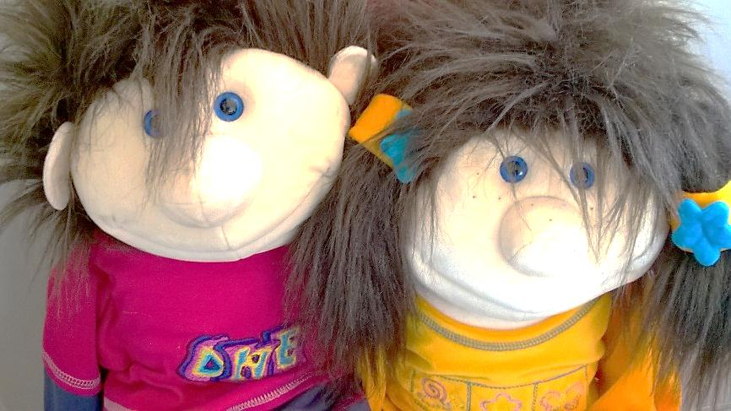

Section One Time to go to School

Overview:
Charlie wakes up and sings ‘Time to go to School.’ Charlie tells us how he wakes himself up in the morning and invites us to sing the song with him. Charlie is excited because he is bringing his new dinosaur in to school to show his best friend, Bella. When Charlie gets to school he is sad because Bella isn't there. Charlie is worried because Bella is missing out on lots of fun things in school.
Potential Activities:
Time to go to School | Teach the children Charlie’s song so they can join in with him.
Wakey wakey, Rise and Shine! | What do you do to help wake yourself up in the morning? Ask the children to demonstrate what they do first thing in the morning. Do they Stretch? Yawn? Shake themselves? Jump out of bed? Sing?
A Healthy Way to start the Day | Discuss a healthy morning routine with the children. How can we be well prepared for the day? A good breakfast, washing our face, making sure our uniform is on right, brushing our teeth.
Feeling Blue | Ask the children how they would feel if their best friend didn't come to school for 3 days in a row? Would they be worried? Sad? Disappointed? Lonely?
Questions based on storyline | Why does Charlie sing his song every morning?  What else does Charlie do in the mornings before going to school?  Why is Charlie so excited about going to school today?  How does Charlie feel when he realises Bella isn't at school again today?  What is Charlie excited about doing in school today?
Section Two Bella’s Boring Day

Overview:
Bella sings a song about the different reasons why she doesn't go to school. She has been off for 3 days now and is feeling very bored. Bella starts thinking about Charlie and all of her other friends at school, wondering what they are doing. She is a bit worried. What if she doesn’t understand what they are talking about when she goes back?
Charlie wakes up the next morning and sings his song. Charlie thinks about why it is sometimes hard to get out of bed in the morning. He really hopes that Bella will be back to school today. He can’t wait to see her.

Potential Activities:
I’m so bored! | Ask the children if they have ever been really bored. What did it feel like? How long does it take to get bored? Can they pull a bored face? What does our body language look like when we are bored?
Missing Out | Talk about all the things that children would miss out on if they didn’t come to school.
Look what I’ve Learnt! | Use blocks to build 2 towers, one showing how much a child learns if they are in school every day and one representing a child with poor attendance.
Two Different Tuesdays | Talk through how different Charlie and Bella’s days were and ask the children who had a better day.
Questions based on storyline | Should Bella have stayed at home for 3 days?  Why is Bella not happy at home?  What is Bella worried about?  Why is it hard to get out of bed?
Section Three Bella’s Back!

Overview:
Bella is very excited to be back at school and Charlie is really happy to see her. He has missed his best friend. But Charlie can’t believe that Bella only had a sniffly nose, and that she forgot to bring a note to Miss Smith. Even Miss Smith has a sniffly nose and she didn’t stay at home!
Charlie tells Bella about all the things they have been learning in school. Bella is sad, she has missed a lot. Bella decides that she will only stay off school to look after her baby brother or if her goldfish dies or if she is just too tired. Charlie shakes his head and explains when it is ok to miss school.

Potential Activities:

Bella Misses out | Use the images to help the children talk about all the things Bella has missed out on
Yes or No | Use the images to discuss what are good reasons for staying off school and when we shouldn’t stay at home
Oh Oh, Late AGAIN! | Ask the children what they like to do as soon as they come into school. Highlight that we miss out on all these things if we come into school late.
Questions based on storyline | What did Charlie think about Bella staying at home for 3 days because of a sniffly nose?  How did Bella feel when she heard about all the things she had missed out on?  What did Bella forget to do?  What was the main thing Bella missed?

Dialogues with the Puppets

Charlie and Bella are available to borrow from the Education Welfare Service (Tullygallly office) for use as an additional resource. Below are examples of dialogues between Charlie, Bella and the pupils. They are split over the 3 sections.

Section One: Time to go to School

Teacher: Hi Charlie!

Charlie: Hello Mr…/Ms…

Teacher: Say hello to Charlie boys and girls

Class: Hello Charlie

Charlie: Hi boys and girls

Teacher: Did you have a good day at school Charlie?

Charlie: It was ok. We did lots of fun stuff and I learnt new things but I was a bit sad.

Teacher: Why were you sad Charlie?

Charlie: Well when I woke up this morning I was so excited! I got a new toy dinosaur and I was allowed to bring it into to school to show my best friend Bella! But Bella didn't come to school today. That’s 3 days this week she hasn't been at school and I really miss her.

Teacher: Oh dear Charlie. What do you think is wrong with Bella?
Charlie: I don’t know. She must be VERY sick because she has been off for 3 whole days! Or maybe something sad has happened and she has to stay at home. What do you think boys and girls?

Class: (Give ideas about why Bella is off school)

Charlie: Do you miss your friends when they aren't at school boys and girls?

Class: (Give answers)

Charlie: I really miss Bella. We have lots of fun together. We play together, we eat lunch together and we talk about all the new things we are learning. I hope she comes back soon.

Teacher: Will you come back and see us again soon Charlie.

Charlie: Yes! And maybe Bella can come too!

Teacher: The boys and girls love your song about school. Will we all sing it together?

SECTION 2: Bella’s Boring Day

Teacher: Hello Bella

Bella: Hello Mr…/Ms…

Teacher: Say hello to Bella boys and girls

Class: Hello Bella

Bella: Hi boys and girls

Teacher: How are you today Bella?

Bella: Mmm mmm, I am ok. (sniffles)

Teacher: We met your friend Charlie yesterday, didn’t we boys and girls?

Class: (Answers)

Teacher: Charlie was very worried about you because you haven't been to school for 3 days. You must be very sick.

Bella: Oh I miss Charlie! He is my best friend in the whole world. Did you like Charlie boys and girls?

Class: (Answers)

Bella: Was he angry with me for not being in school?

Class: (Answers)

Bella: But I had to stay at home because mmm, well, mmm, I had a sniffly nose.

Teacher: Oh Bella! you don't have to stay at home with a sniffly nose, unless you have a really bad cold. Lots of boys and girls have sniffly noses and they still come to school. Thats why we have boxes of tissues! Do you need a tissue?

Bella: Yes please. (Blows into the tissue) Have any of you boys and girls got sniffly noses today?

Class: Answers (Offer them a tissue)

Bella: Oh I should have gone to school today. I was SO bored at home anyway and I missed all my friends. And now I am really worried.

Teacher: Oh dear Bella, what are you so worried about?

Bella: All the boys in girls in my class will have learnt new things and I won't know what the teacher is talking about.

Teacher: It can be really difficult going back to school after missing days Bella. But Charlie and your other friends will help you. Do you think you will go back to school tomorrow?

Bella: Oh I hope so! I can’t wait to see everyone! Do you think Charlie will be pleased to see me boys and girls?

Class: (Answer)

SECTION 3: Bella’s Back

Teacher: Hello Charlie

Charlie: Hello Mr…/Ms…Hello boys and girls. How are you today?

Class: Hello Charlie. (Give answers)

Charlie: Oh I am so happy today! Can you guess why?

Class: Give answers.

Charlie: That’s right. My best friend Bella came back to school today! I was so happy to see her. Do you know why she wasn't at school boys and girls?

Class: (Give answers)

Charlie: That’s right boys and girls. She had a sniffly nose. Imagine staying at home because you have a sniffly nose. You can only stay at home if you have a proper cold. My teacher has a sniffly nose all the time! Does your teacher have a sniffly nose boys and girls?

Class: (Give answers)

Teacher: I have to come in to school even if I have a sniffly nose, or a tickly throat, or a slight cough. I would miss all the boys and girls if I wasn't here!

Charlie: Oh I would really miss my friends if I wasn't in school. And I would miss learning all about shapes and letters and monkeys and dinosaurs! Bella missed SO much. What things would you miss if you didn't come to school boys and girls?

Class: (Give answers)

Teacher: It’s ok to stay at home sometimes isn’t it Charlie?

Charlie: Oh yes Mr/Ms….. If you have a really bad cold or a sick tummy, it’s important to stay at home and get better. Isn’t that right boys and girls?

Class: (Answer)

Charlie: And sometimes boys and girls need to stay at home because something very sad has happened. And that’s ok too.

Teacher: That’s right Charlie. Thank you so much for coming and talking to us. Would you like to sing your song one last time with the boys and girls?

Charlie: Yes please! I think it is great that all you boys and girls are in school today and make sure you only miss a day if you REALLY have to because SCHOOL IS COOL FOR EVERYONE!

Charlie’s Song

Yawn and stretch and reach up high, time to go to school.
Raise your hands up to the sky, time to go to school.
We learn to count. We learn to spell. We learn to sing and dance as well.
Raise your hands up, say ‘HIGH FIVE’!
School is really cool.
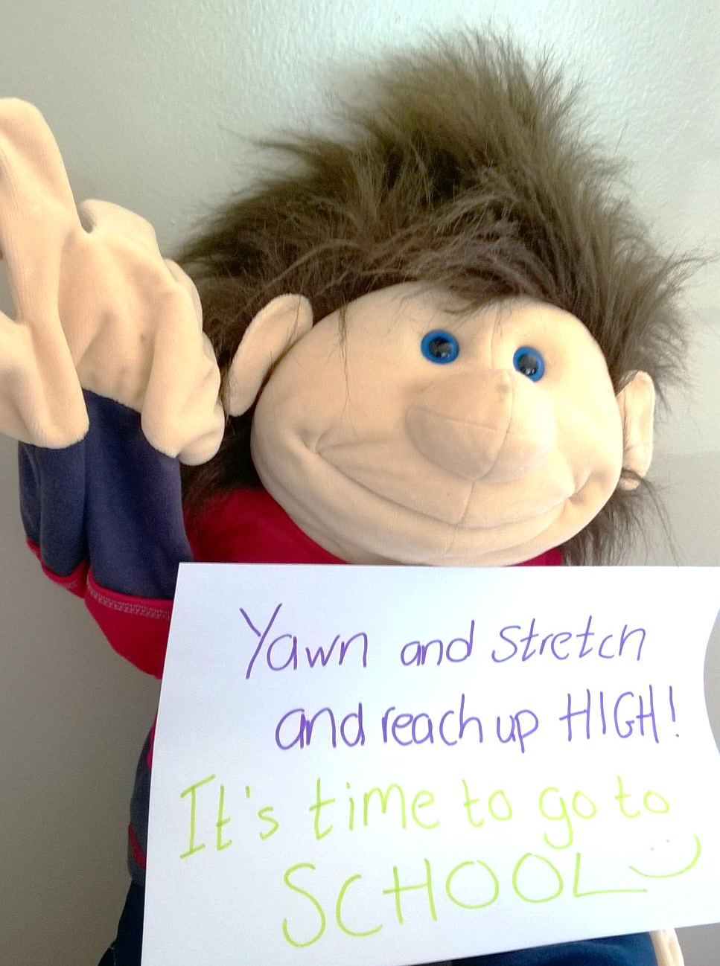

What has Bella missed in school?

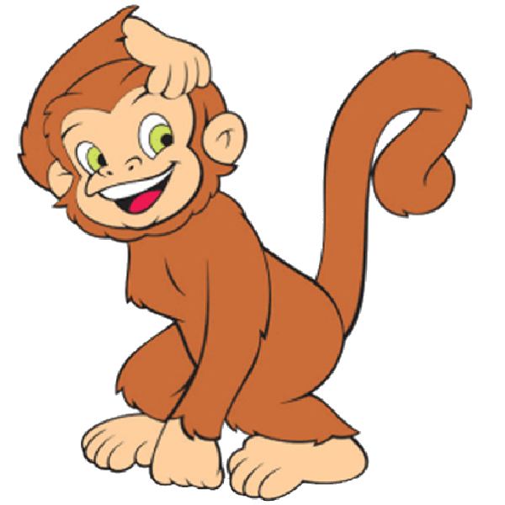
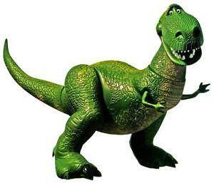

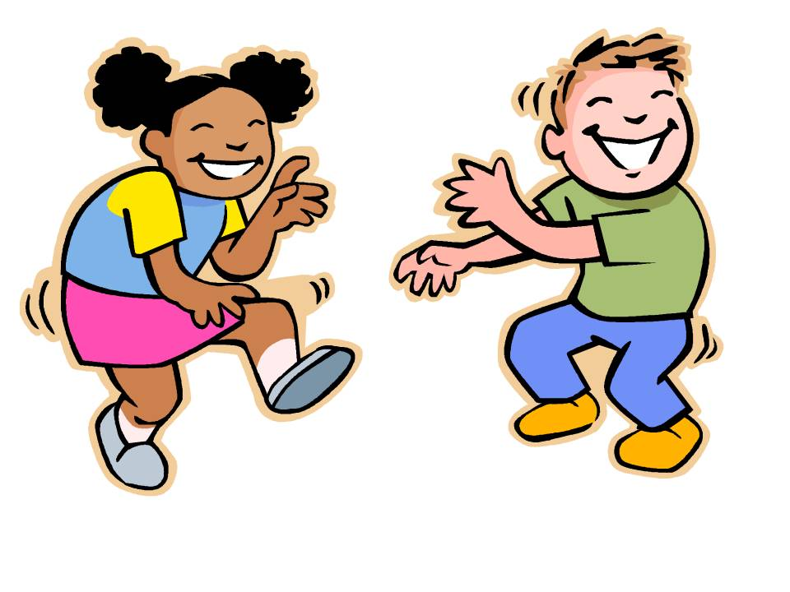
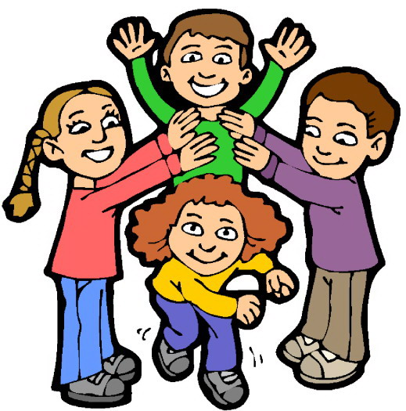

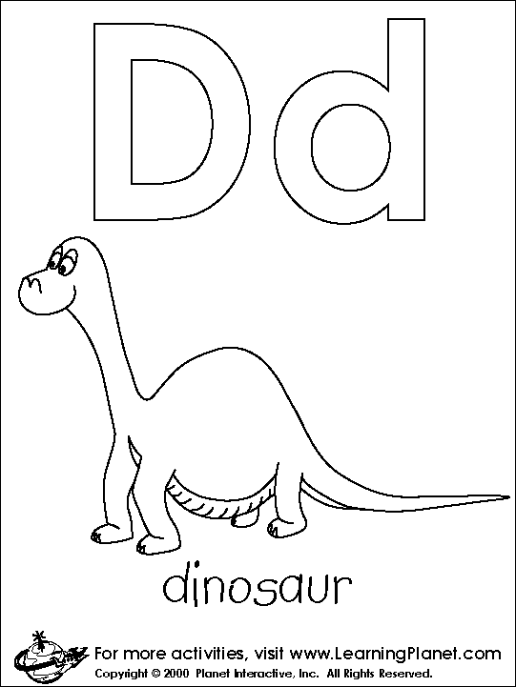
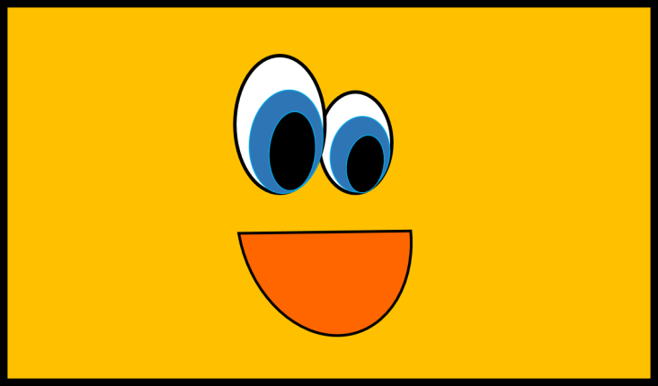

Reasons to stay off school. Yes or no?
