

[www.movingforward.me](http://www.movingforward.me)

**Transition**

**From Year 10 to Year 11**

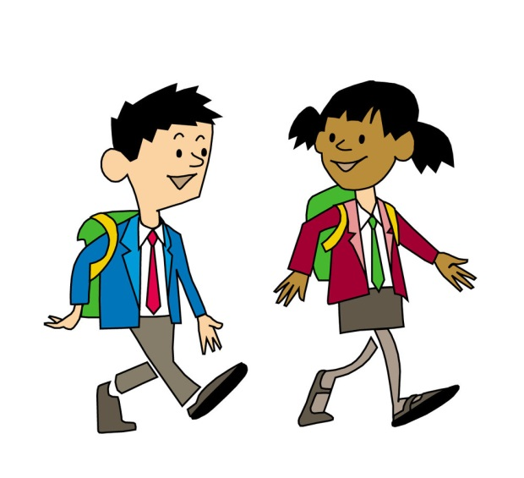

NAME: _________________________________

DATE: _________________________________

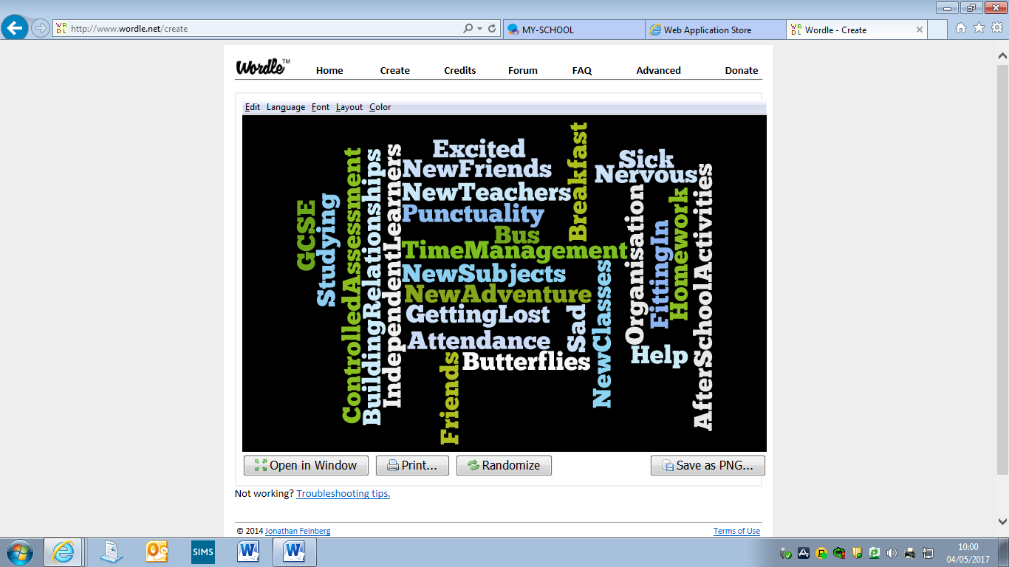

**Contents Page**

Page 4 Travelling to School

Page 5 Getting Lost

Page 6 Making New Friends

Page 7 Fitting into new classes/new Teachers

Page 8 GCSEs

Page 9 Homework

Page 10 Where can I get help with my school work?

Page 11 If I have worries who can I turn to?

Page 12 Useful Support websites

Page 13 Notes

**Travelling to School**

 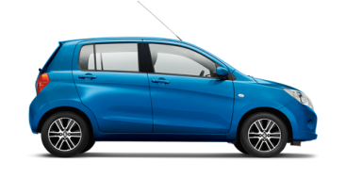

* + If your new school is further away you may have to travel by bus or be driven there. This will mean you may have to get up earlier in the morning, which might mean going to bed earlier at night.
  + no distractions before going to bed to help you sleep better.

[](http://www.bing.com/images/search?view=detailV2&ccid=XYQBvPmS&id=1728F188A284A633DD12DBC8792B815E00D2C66B&thid=OIP.XYQBvPmSfHqWhEGMOg07nACzFb&q=clipart+mobile+phone&simid=608000343591290156&selectedIndex=0&adlt=strict) 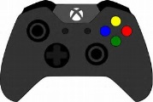  [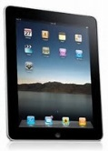](http://www.bing.com/images/search?view=detailV2&ccid=Up6K7yDB&id=C4978C0CF2E0B6A86E53D988093575981F89CB83&thid=OIP.Up6K7yDBINooWRGVYHw2QADWEs&q=clipart+ipad&simid=608006489680576547&selectedIndex=0&adlt=strict)

* + Try to become friends with other students who get the same bus as you, to make the journey to and from school more enjoyable.
  + Get up early enough so you have time for breakfast – the most important meal of the day as it is the fuel to get your body working!
  + If you are going by bus for the first time do a trial run before you start your new school.

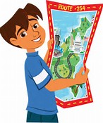**Getting Lost**

* + Check the school website for a map of the school.
  + Find out where the school office is – ask nicely and staff will direct you to your class.
  + Teachers will understand at the beginning, if you are a few minutes late because you are lost – ask the nearest adult or student.
  + Ask at the end of class to find out if any other students are going to the same class as you and walk together.

**Making New Friends**

* + Smile!
  + Join before school/lunchtime/afterschool activities

**Sport Music ICT Drama Gardening Cooking Public Speaking Breakfast Club**

* Talk to people – give yourself a chance to get to know other students and them a chance to get to know you!
* Get to know students in Year 12 who transferred last year – they will reassure you!



**Fitting into new classes/new Teachers**

* + - This will be as daunting for you as it will be for your teachers and class mates; you are new to them, just like they are new to you.
    - Don’t judge students /teachers on the first day.
    - It may take you sometime to settle in to your new school – some students will take longer to settle in than others – that is OK!
    - Listen to any advice you will be given, whether it is from your class mates or teachers.
    - Try to keep up to date with work – don’t be afraid to ask for help!

[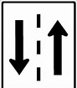](http://www.bing.com/images/search?q=two+way+street+clipart&id=B409B170B47D570783355642E976CEDA5E06890E&FORM=IQFRBA)

* + - You will have to get used to new teachers and have to adjust to different personalities and teaching styles (e.g. Groupwork/independent learning/using interactive whiteboards/discussions/role plays etc.) – this take time but remember it is a two-way street.

**New GCSEs**



* This is something that you should be really EXCITED about!
* Some subjects will be the same as you are studying in your present school and some will be NEW!
* Exams may take place in Year 11 as well as Year 12 – PREPARATION IS THE KEY!

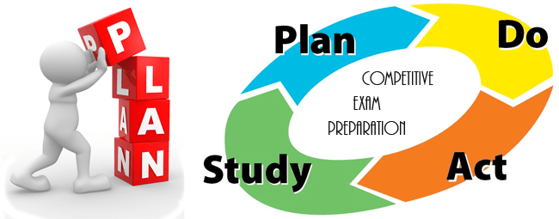

* Controlled Assessment Units – this is an opportunity for you to gain a percentage of your GCSE before sitting your actual exam. It is really good for students who perform better in assessments/practicals than they do in written exam.

**Useful websites**

<https://icould.com/stories/choosing-your-gcse-options/>

[www.movingforward.me](http://www.movingforward.me) (Study/Subject section)

**Homework**

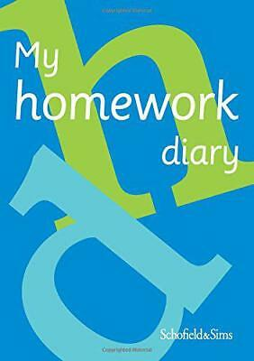

* Organisation and time management are **vital!**



* Record all homework in diaries/planners, **in detail!** For example: complete questions 1-3 on page 24, do not just write ‘finish homework’.
* It is better to complete the homework on the night it is set or as soon as possible so the information is fresh in your head.
* Organise your books and school bag every night – “pack and check” – always check your timetable to see what books you will need for the next day.

**What happens if there is homework you don’t understand?**

**ASK…**

Brothers/

sisters

Parents/

Guardians

Look on the Internet

Friends/

classmates

Subject

Teacher

**Where Can I Get Help with my school work?**

**Activity Booklets**

**Apps/Websites**

**Classmates**

**Family Members**

**Teachers**

**Library**

**Useful Study websites**

[www.movingforward.me](http://www.movingforward.me) (Study/Subject Section)

GCSE Bitesize – [www.bbc.com/bitesize](http://www.bbc.com/bitesize)

S-Cool – [www.s-cool.co.uk](http://www.s-cool.co.uk)

Get Revising – [www.getrevising.co.uk](http://www.getrevising.co.uk)

BBC iWonder – [www.bbc.co.uk/iwonder](http://www.bbc.co.uk/iwonder)

Corbett maths- [www.corbettmaths.com](http://www.corbettmaths.com)

**If I have worries who can I turn to?**



* **Parents**

* **Friends**
* **Form Teacher** (Your form teacher will have most contact with you and is there to help so don’t worry about approaching them with any problems you may have.
* **Year Head** (Again your Year Head is there to help with any worries so don’t fell afraid to approach them)
* **Designated Teacher** (Your school will have specific teachers who are responsible for child protection and there will be photos of them in your school. Go to them if you find yourself fearful for any reason or bullied)
* **School Counsellor** (every Secondary School has a counsellor who comes in once a week and you can ask to be referred or some schools have a box to put your request in and it remains anonymous)

* **EWO** (There is a link EWO in every school)

**Useful Support websites**

**EMOTIONAL WELLBEING/COUNSELLING/SUPPORT**

>> [Northern Area MHI](https://northernareamhi.org.uk/) - [www.northernareamhi.org.uk](http://www.northernareamhi.org.uk)

>> [Mind Your Head](http://www.mindingyourhead.info/) - [www.mindingyourhead.info](http://www.mindingyourhead.info)

>> [iMatter](http://www.deni.gov.uk/index/pupils-and-parents/pupils/your-emotional-health-and-wellbeing.htm%20) - [www.education-ni.gov.uk/articles/imatter-programme](http://www.education-ni.gov.uk/articles/imatter-programme)

>> [Family Support NI](http://www.familysupportni.gov.uk/) - [www.familysupportni.gov.uk](http://www.familysupportni.gov.uk)

>> [Young Healthy Minds](http://www.younghealthymindsni.co.uk/) - <http://www.younghealthymindsni.co.uk/>

>> [Kinship Care NI](http://www.kinshipcareni.com/) - <http://kinshipcareni.com>

>> [Lighthouse Charity](http://www.lighthousecharity.com/) - <http://lighthousecharity.com>

>> [Autism NI](http://www.autismni.org/) - <http://www.autismni.org/>

>> [Action Mental Health](http://www.amh.org.uk/) - <https://www.amh.org.uk/>

**INTERCULTURAL SUPPORT**

>> [Afro-Community Support Organisation Northern Ireland](https://www.acsoni.org/) - [www.acsoni.org](http://www.acsoni.org)

>> [Artsekta](http://www.artsekta.org.uk/) - [www.artsekta.org.uk](http://www.artsekta.org.uk)

>> [Belfast Islamic Centre](http://www.belfastislamiccentre.org.uk/) - <http://belfastislamiccentre.org.uk/>

>> [Chinese Welfare Association](http://www.cwa-ni.org/) - [www.cwa-ni.org](http://www.cwa-ni.org)

>> [Craic NI](http://www.craicni.com/) - <http://www.craicni.com/>

>> [Indian Community Centre](http://www.iccbelfast.com/) - [www.cwa-ni.org](http://www.cwa-ni.org)

>> [Jewish Belfast Community](http://www.belfastjewishcommunity.org.uk/) - <http://www.belfastjewishcommunity.org.uk/>

>> [Polish Educational and Cultural Association](http://www.peca-ni.org/home/) - <http://peca-ni.org/home/>

>> [Bulgarian School](http://www.bgschoolni.co.uk/en/) - <http://www.bgschoolni.co.uk/en/>

**Notes**

________________________________________________________________________________________________________________________________________________________________________________________________________________________________________________________________________________________________________________________________________________________________________________________________________________________________________________________________________________________________________________________________________________________________________________________________________________________________________________________________________________________________________________________________________________________________________________________________________________________________________________________________________________________________________________________________________________________________________________________________________________________________________________________________________________________________________________________________________________________________________________________________________________________________________________________________________________________________________________________________________________________________________________________________________________________________________________________________________________________________________________________________________________________________________________________________________________________________________________________________________________________________________________________________________________________________________________________________________________________________________________________________________________________________________________________________________________________________________________________________________________________________________________