Lesson Plan for P7 Study Programme
Page 2
Organised
Using the letters going down the page ask the class to think of words that are relevant to being organised and write them beside each letter. (See examples below)
O Be organised and get everything in Order before you start
R Read lots
G Get organised/gather equipment and books before you start
A Allow others to help/arrange everything before sitting down to start/Aqua for water, drink lots
N Make neat and tidy notes
I Increase your knowledge by studying
S Study a little everyday/ a good nights sleep is important
E Examples can help you remember/eat healthy/do lots of exercise
D Try to work at a desk not your bed

Page 3
Talk about why teachers give homework:-
- Homework gives you the chance to reinforce what you have learnt that day in class.
- It also encourages you to begin to learn how to independently work at home.
- It is also a way of keeping parents informed about what you are learning in school.
Where can I get help:-
Get pupils to tell you where they think they can get help. Remind them that the internet is a good and useful help if used safely. Go through the sign post for help with them on page3.
Page 4
Doing homework or revising.
Ask the pupils where they study and discuss the four tips on the diagram with them:-
When: - early in the day, not late at night or on the night before the homework is due.
Where: -
- Not on the bed
- In a quiet place where you will not be disturbed
- If possible at a desk/table and preferably where there is natural light
How: -
- By being organised
- Using school books
- Using the internet to research subjects
What: -
- Do set homework
- Take time to revise at least one subject per night
Encourage pupils to do a little revision each day and remind them to get up and move about and drink lots of water. For Primary school pupils 45 minutes a day is probably enough revision/studying.
Getting ready
Advise pupils that it is important to read through questions set for homework or tests and highlight the important points. They must only answer what is asked.
Page 5
Using spider diagrams
The diagram provided is an example, using it as guidance give the pupils a black sheet and ask them to do their own diagram. You can ascertain a subject they are currently doing and get them to do their own diagram. It can be helpful and to reinforce the message on the diagram if it is colourful.
For example put English in the centre and create a spider diagram that gives the definition and examples of a Noun, Verb, Adverb and Adjective.
What is a Noun: - A Person, Place or Thing e.g. Teacher, New York and Book
What is a Verb: - A doing word e.g. reading, walking, dancing etc.
What is an Adverb: - A word that describes a verb e.g. quietly, briskly, energetically etc.
What is an Adjective: - A describing word e.g. grumpy, tiny, gloomy etc.

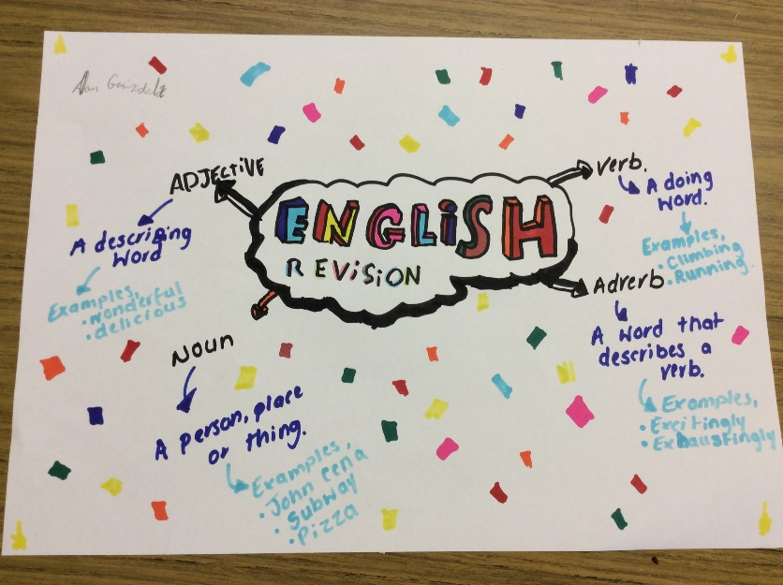

Page 6
Flash cards
- If possible provide each pupil with three flash cards
- Get them to write a Question on one side and anAnswer on the other. Then ask them to write the following Questions/Answers on the each card giving examples:-
- Question-What is a Square Number? Answer–The result of multiplying a number by itself e.g. 2²(2x2=4)
- Question-What is a prime Number? Answer–A number that can only be divided by itself and 1 e.g. 2, 3, 5,7,11 etc.(2 is the only even prime number,2divided by 2 =1, 2divided by 1 =2)
- Question-What is a Cubed number? Answer–A number that is multiplied by itself and then multiplied by itself again e.g. 2³ (2x2x2=8)
- Ask for two volunteers and get one to use the cards to ask their classmate the questions on the cards. The classmate then answers the questions and they go through the three cards. This will show them how to use flash cards for revising.

