Year 8 students should use this booklet to help with their workload this year.

**Test Preparation**

**Organisational skills**

**Learning Styles Questionnaire**

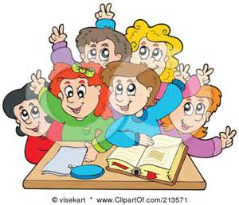

**Managing homework**

**Listening skills**

**Transition:**

**Lots of teachers**

**Lots of subjects!**

**Self-Evaluation**

**Study place**

**Name: ___________________________ Class: _________**

**Contents Page**

Page 2-5 Learning Preferences Questionnaire

Page 6 Organisational Skills

Page 7 Managing Homework

Page 8 Where can I get help?

Page 9 Study Place

Page10 Test Preparation

Page 11 Notes

This questionnaire will help you discover what kind of learner you are. Read each row and tick the ONE option that is most like you. (<http://www.brainboxx.co.uk/a3_aspects/pages/vak_quest.htm>)

**Learning Preference Questionnaire**

|  |  |  |  |  |
| --- | --- | --- | --- | --- |
| blackboard | A. I prefer lessons where we can discuss things. | V. I prefer lessons where there is something to look at (like a picture, chart, diagram or video) or something to draw. | K. I prefer lessons where we can do something practical – or at least move around. |  |
| paperclips | K. I often fiddle with things in class (a pen, paper clip or rubber band.) | A. I often sing or hum to myself in class. | V. I often doodle in class. |  |
| juggleboy | K. When learning a new skill, I prefer to just get on with it. | A. When learning a new skill, I prefer someone to explain to me how to do it. | V. When learning a new skill, I prefer to watch someone else show me how to do it. |  |
| tellyad | V. When the adverts come on the telly – I like to watch them. | K. When the adverts come on the telly – I get up and do something. | A. When the adverts come on the telly – I like to sing along with them. |  |
| discinter | A. I would prefer to listen to a story. | V. I would prefer to see a comic strip of a story. | K. I would prefer to act out a story. |  |
| memory | K. I am good at learning physical skills. | A. I have a good memory for people’s names. | V. I have a good memory for faces. |  |
| teacher | V. I prefer teachers who use diagrams to show us things. | K. I prefer teachers who get us to do something. | A. I prefer teachers who explain things to us. |  |
| catapult | A. If I get in trouble in class, it’s for talking. | V. If I get in trouble in class, it’s for drawing on the desk or all over my books. | K. If I get in trouble in class it’s for fidgeting. |  |
| journey | V. On a long journey I like to look at the scenery or read a book. | K. On a long journey I can’t wait until we stop so I can walk around. | A. On a long journey I like to listen to music or talk to the other travellers. |  |
| gestures | K. I use my hands a lot when I am talking. | A. When I am discussing something, I sometimes use words my friends don’t know. | V. When I am discussing something, I like to doodle. |  |
| mike | K. If I could be famous, I would be a sports-person (or dancer). | V. If I could be famous, I would be a film-star. | A. If I could be famous, I would be a singer. |  |
| snowballs | K. I would rather go outside and play. | V. I would rather watch my favourite TV programme. | A. I would rather listen to my favourite music. |  |
| window | V. I get distracted in class if I can see something outside the window. | A. I get distracted in class if I can hear something happening outside. | K. I lose concentration if I have to sit still for a long time. |  |
| bigbrush | V. I am good at drawing. | K. I am good at making things. | A. I am a good listener. |  |
| headphones | A. Out of these 3 jobs - I would prefer to be a radio DJ (or presenter) | K. Out of these 3 jobs - I would prefer to be a mechanic. | V. Out of these 3 jobs - I would prefer to be an artist (or designer). |  |
| rugby | K. In my spare time I would prefer to do something physical, such as sport or dancing. | V. In my spare time I would prefer to watch TV or a video. | A. In my spare time I would prefer to listen to music or chat with friends. |  |
| rubik | V. The type of puzzle I would prefer is "Spot the difference". | A. The type of puzzle I would prefer is "Name that tune". | K. The type of puzzle I would prefer is "Rubik's cube". |  |
| lego | A. If I needed to build a Lego model, I would get someone to explain how or to read the instructions to me. | K. If I needed to build a Lego model, I would try to work out which bits fit together. | V. If I needed to build a Lego model, I would follow the diagram or the picture on the packet. |  |

**When you have ticked one option in each row, circle the appropriate letter in the right-hand column,** **and then count up how many of each letter you scored.**

|  |  |  |
| --- | --- | --- |
| **Learning Preference** | **I have scored…** | **I am mostly…** |
| If you scored mainly V's, you are a **VISUAL** learner. |  |  |
| If you scored mainly A's, you are an **AUDITORY** learner. |  |
| If you scored mainly K's, you are a **KINAESTHETIC** learner. |  |

**Visual learners** prefer to:

* Draw pictures and diagrams
* Colour code their work
* Use different coloured paper, pens etc.
* Use their own system of symbols etc.
* Create images and scenes in their minds

**j0238189**

**Auditory learners** prefer to:

* Say their work aloud
* Give presentations to an imaginary audience
* Record notes on a phone or iPad
* Use silly noises to remember things
* Hear the information in their mind
* Play instrumental music

**j0349645**

**Kinaesthetic learners** prefer to:

* Do actions when learning key facts
* Walk about when learning
* Find it harder to sit at a desk
* Add emotions and textures to exaggerate information
* Try to experience what they are learning

**j0292058**

**Organisational Skills**

In order to study effectively it is important to be organised. Make sure you have the books and equipment you need to study.

* 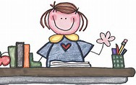Folders
* File Dividers
* Poly Pockets
* Paper
* Pens
* Pencils
* Highlighters
* Rubber
* Protractor
* Compass
* Colouring Pencils
* 30cm Ruler
* Scissors
* Glue
* Calculator
* Sharpener
* Dictionary
* Thesaurus

**How organised are you?**

(Please tick)

* Very organised
* Organised
* Not organised

**Managing Homework**

What could you be asked to do for homework?

[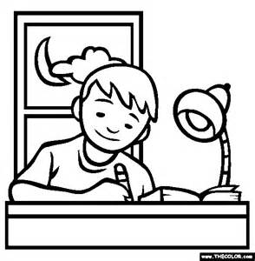](http://www.bing.com/images/search?q=writing+for+homework&view=detailv2&&id=601CCD0E5FE55ECC53AD466EF781291839B6DE3B&selectedIndex=18&ccid=g1fBCkfl&simid=608016238523974166&thid=OIP.M8357c10a47e5d9930403e61c3011d3bdH0)Some examples include:

* Written tasks
* [](http://www.bing.com/images/search?q=reading+for+enjoyment&view=detailv2&&id=9286725B6D7F64DA1C660407BD8D91FDFA2BF489&selectedIndex=2&ccid=hmG0mltm&simid=608020224252251648&thid=OIP.M8661b49a5b66e9adfee0abc045212bfdo0)Research and reading tasks
* Learning
* Creative (making and designing)
* Group work
* Reading for enjoyment, for further development or reading for research

***Top Tips for doing homework!***

* Always record the information in your homework diary

E.g. French – write out vocabulary about my family, into vocabulary book. Due: Monday 28th September.

* Always try to complete homework tasks when they are set

E.g. particularly subjects you only have once a week.

* Always place a tick against tasks when completed
* If you are unsure about a question, ask for help
* Show your homework to a parent/guardian and let them see how well you are doing
* ALWAYS complete homework to the best of your ability
* Don’t make excuses for not doing your homework!

**How could I improve my homework?**

__________________________________________________________________________________________________________________________________________

**How long do you spend doing homework?**

_______________

**Where can I get help?**

**Maths Apps/Websites**

**Activity Booklets**

**Peers**

**Family Members**

**Teachers**

**Study Place**

**WHEN?**

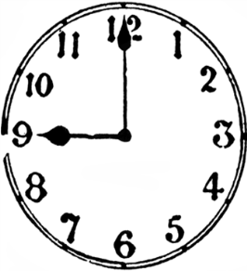

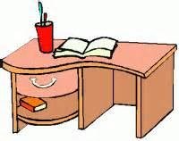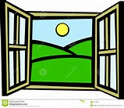**WHERE?**

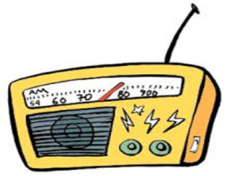

**HOW? WHAT?**

**How do you study?**

**________________________________________________________________________________________________________________________________________________________________________________________________________**

**Test Preparation**

|  |  |  |  |  |  |  |
| --- | --- | --- | --- | --- | --- | --- |
| Monday | Tuesday | Wednesday | Thursday | Friday | Saturday | Sunday |
|  |  |  |  |  |  |  |
|  |  |  |  |  |  |  |

1. Create a revision timetable…
2. **WARM UP**

* To get your brain ready for action try doing a few mental stretches:
* Sort out your books/arrange your pens/pencils
* Read through the instructions carefully
* Think about the purpose of the work

**Top Tip:**

Study for 25-30 minutes

Take a 5 minute break

1. **CONCENTRTE**

* **Be active – don’t just sit there!**
* **Now work hard**
* Draw the diagram
* Complete the exercises
* Make the notes
* Plan the answer

1. **COOL DOWN**

Check how you have done

* Proof read your work – check spellings
* Test yourself or ask some-one to test you
* Assess what you have achieved

**Notes Page**

________________________________________________________________________________________________________________________________________________________________________________________________________________________________________________________________________________________________________________________________________________________________________________________________________________________________________________________________________________________________________________________________________________________________________________________________________________________________________________________________________________________________________________________________________________________________________________________________________________________________________________________________________________________________________________________________________________________________________________________________________________________________________________________________________________________________________________________________________________________________________________________________________________________________________________________________________________________________________________________________________________________________________________________________________________________________________________________________________________________________________________________________________________________________________________________________________________________________________________________________________________________________________________________________________________________________________________________________________________________________________________________________________________________________________________________________________________________________________________________________________________________________________________