

[www.movingforward.me](http://www.movingforward.me)

**Transition**

**Into GCSE’s for Year 10 Pupils**



NAME: _________________________________

DATE: _________________________________

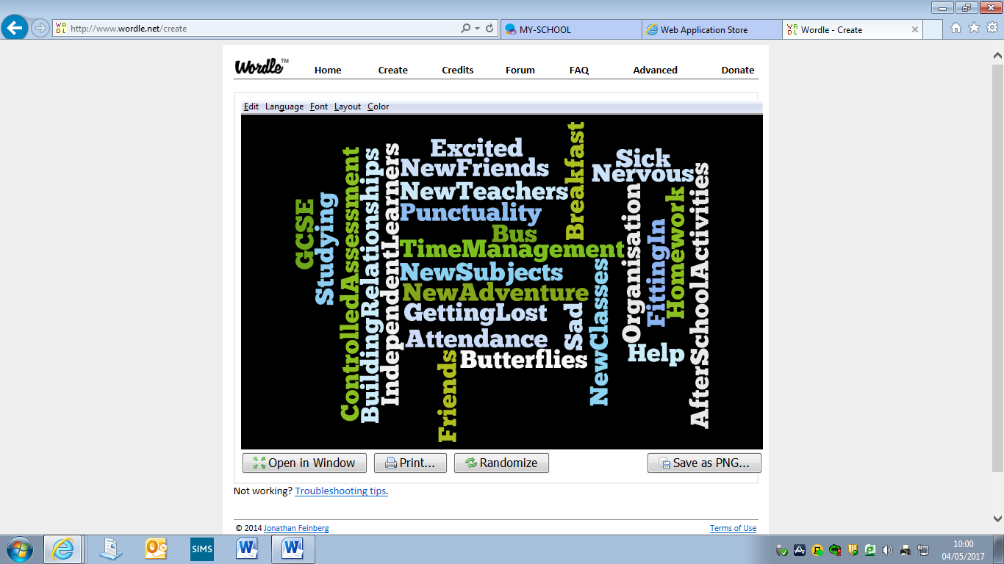

**Contents Page**

Page 4-5 Developing new friendships and working with new teachers

Page 6 GCSEs

Pages 7 Homework

Page 8 Tips for doing your homework and studying

Page 9-12 Tips for sitting exams and tests

Page 13 If I am feeling anxious who can I turn to?

Page 14-16 Useful support websites

Page 17 Notes

**Developing New Friendships and working with New Teachers**

**You may find yourself with a new set of classmates depending on the subjects you have chosen.**

* + Smile!
  + If you haven’t already done so join before school/lunchtime/afterschool activities, they are a great way to get to know other pupils with the same interest as yourself.

**As you approach the end of your education you will be looking at developing a CV/Personal Statement and the more you can include on it regarding extra curriculum activities the better.**

**Sport Music ICT Drama Gardening Cooking Public Speaking Breakfast Club**

* + - You may find yourself with a new set of classmates depending on the subjects you have chosen on your first day in Year 11; give yourself time to get used to them. Talk to and mix with your new classmates and remember your other friends are still about and you can see them at break and lunchtime.
    - As with your new classmates don’t judge any new teachers. Getting used to new teachers may mean having to adjust to different personalities and teaching styles this takes time but remember it is a two-way street. You are as new to your teacher as they are to you. However you may still have the same teachers for some subjects.
    - It may take you sometime to settle in to your new timetable and subjects you have been there before in Year 8, just give it some time.
    - Listen to any advice you will be given, whether it is from your classmates or teachers.
    - Try to keep up to date with work – don’t be afraid to ask for help!

**GCSEs**

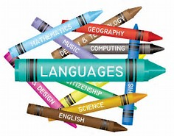

* This is something that you should be really EXCITED about!
* Some subjects will be the same as you are studying presently in school and some will be NEW!
* Exams may take place in Year 11 as well as Year 12 – PREPARATION IS THE KEY!

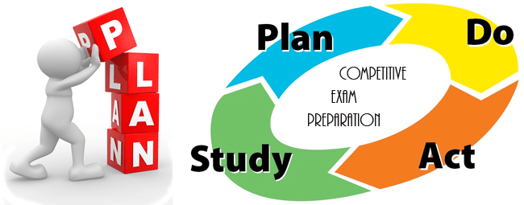

* Controlled Assessment Units – this is an opportunity for you to gain a percentage of your GCSE before sitting your actual exam. It is really good for students who perform better in assessments/practicals than they do in written exam.

**Homework**

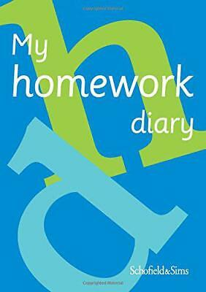

* Organisation and time management are **vital!**



* Record all homework in diaries/planners, **in detail!** For example: complete questions 1-3 on page 24, do not just write ‘finish homework’.
* It is better to complete the homework on the night it is set or as soon as possible so the information is fresh in your head.
* Organise your books and school bag every night – “pack and check” – always check your timetable to see what books you will need for the next day.

**What happens if there is homework you don’t understand?**

**ASK…**

Brothers/

Sisters

Parents/

Guardians

Look on the Internet

Friends/

Classmates

Subject

Teacher

**Tips for doing your homework and studying**

**Establish a consistent schedule and healthy routines.**

It is important to establish a daily after-school routine. Allowing for time to unwind and play is certainly acceptable and something to be encouraged. However, set aside a time to sit down to do your homework each day. If you do not have homework everyday use the time to study for exams or read and research to enhance your knowledge of the subject. Extra information in exam questions could improve your mark.

**Eliminate or at least limit distractions during study/homework time.** Designate an area in your home that’s quiet and free from major distractions as the place to complete your homework study. This can help you to accomplish more and do higher-quality work with fewer distractions to lure your attention away from your studies. Remove major distractors such as TV, video games, phones, loud music, and anything else that could distract you.

Before starting ensure you have all essential materials and resources - pencils, pens, paper, markers, a calculator, a computer with Internet access (if needed for research etc. ) You shouldn’t have to stop doing homework to search for materials and resources, this could be disruptive.

**Take breaks.**

Take short breaks every 20-30 minutes. Your brain is a computer and needs time to rest and digest information.

**Make sure you get enough sleep.** A good night’s sleep is one of the most important ingredients in success at school.

**Tips for sitting exams and tests**

* Read your question through and then read it again.
* Highlight main points to be answered
* Reread before answering
* Write clearly
* Answer the question exactly as it is asked
* Do not waffle, be exact and to the point
* Read over your work, check you have answered the question correctly and also check your grammar and spelling.

**For Exams, you'll need to bring:**

* Pens (Blue or Black only)
* A pencil sharpener.
* A good eraser.
* Ruler
* Maths Set
* Calculators (Scientific)
* Water – clear bottle and no label.

**Command words and definitions.**

You will need to become familiar with and understand key command words that will appear in GCSE exam questions. Command words are the words and phrases used in exams and other assessment tasks that tell students how they should answer the question.

**Command Word What you have to do**

|  |  |
| --- | --- |
| **Analyse** | Take apart an idea, concept or statement and examine and criticise its sub-parts in detail. You have to be methodical and logical. |
| **Assess** | Describe a topic’s positive and negative aspects and say how useful or successful it is. |
| **Criticise** | Point out a topic’s mistakes or weaknesses as well as its favourable aspects. Give a balanced answer (this will involve some *analysis* first). |
| **Compare** | Put items side by side to see their similarities and differences – a balanced (objective) answer is required. |
| **Contrast** | Emphasise the differences between two things. |
| **Define** | Give the meaning of an idea. |
| **Describe** | Give details of processes, properties, events and so on. |
| **Discuss** | Describe, explain, give examples, points for and against, then analyse and evaluate the results. |
| **Evaluate** | Similar to *discuss*, but with more emphasis on a judgement in the conclusion. |
| **Examine** | Take apart and describe a concept in great detail. |
| **Explain** | Give detailed reasons for an idea, principle or result, situation, attitude and so on. |
| **Illustrate** | Give concrete examples – including figures or diagrams. *Illustrate* is usually added on to another instruction. |
| **Interpret** | Explain and comment on the subject and make a judgement  (evaluation). |
| **Justify** | Give reasons to support a statement – it may be a negative statement, so be careful! |
| **List** | Provide an itemised series of parts, reasons or qualities, possibly in a table. |
| **Prove/disprove** | Provide evidence for or against and demonstrate logical argument and reasoning – you often have to do this for abstract or scientific subjects. |
| **Relate** | Emphasise the links, connections and associations, probably with some analysis. |
| **Review** | Give a critically assessment on the main aspects of a subject. |
| **State** | Relate the relevant points briefly – you don’t need to make a lengthy discussion or give minor details. |
| **Suggest** | Give possible reasons – analyse, interpret and evaluate. |
| **Summarise or outline** | Just give the main points, not the details, be concise and short |
| **Trace** | Give a brief description of the logical or chronological stages of the development of a theory, story line, process a person’s life and so on. Often used in historical questions. |

**If I am feeling anxious who can I turn to?**



* **Parents**

* **Friends**
* **Form Teacher** (Your form teacher will have most contact with you and is there to help so don’t worry about approaching them with any problems you may have.
* **Year Head** (Again your Year Head is there to help with any worries so don’t feel afraid to approach them)
* **Designated Teacher** (Your school will have specific teachers who are responsible for child protection and there will be photos of them in your school. Go to them if you find yourself fearful for any reason or bullied)
* **School Counsellor** (every Secondary School has a counsellor who comes in once a week and you can ask to be referred or some schools have a box to put your request in and it remains anonymous)

* **Education Welfare Officer (EWO)** (There is a link EWO in every school)

**Useful Support websites**

**Choosing Gcse subjects**

<https://icould.com/stories/choosing-your-gcse-options/>

[www.movingforward.me](http://www.movingforward.me) (Study/Subject section)

**Study websites**

GCSE Bitesize – [www.bbc.com/bitesize](http://www.bbc.com/bitesize)

Ks3 bitesize- https://www.bbc.co.uk/bitesize/levels

MyMaths- [www.mymaths.co.uk](http://www.mymaths.co.uk)

S-Cool – [www.s-cool.co.uk](http://www.s-cool.co.uk)

Get Revising – [www.getrevising.co.uk](http://www.getrevising.co.uk)

BBC iWonder – [www.bbc.co.uk/iwonder](http://www.bbc.co.uk/iwonder)

Corbett maths- [www.corbettmaths.com](http://www.corbettmaths.com)

[www.movingforward.me](http://www.movingforward.me) (Study/Subject Section)

**EMOTIONAL WELLBEING/COUNSELLING/SUPPORT**

>> [Northern Area MHI](https://northernareamhi.org.uk/) - [www.northernareamhi.org.uk](http://www.northernareamhi.org.uk)

>> [Mind Your Head](http://www.mindingyourhead.info/) - [www.mindingyourhead.info](http://www.mindingyourhead.info)

>> [iMatter](http://www.deni.gov.uk/index/pupils-and-parents/pupils/your-emotional-health-and-wellbeing.htm%20) - [www.education-ni.gov.uk/articles/imatter-programme](http://www.education-ni.gov.uk/articles/imatter-programme)

>> [Family Support NI](http://www.familysupportni.gov.uk/) - [www.familysupportni.gov.uk](http://www.familysupportni.gov.uk)

>> [Young Healthy Minds](http://www.younghealthymindsni.co.uk/) - <http://www.younghealthymindsni.co.uk/>

>> [Kinship Care NI](http://www.kinshipcareni.com/) - <http://kinshipcareni.com>

>> [Lighthouse Charity](http://www.lighthousecharity.com/) - <http://lighthousecharity.com>

>> [Autism NI](http://www.autismni.org/) - <http://www.autismni.org/>

>> [Action Mental Health](http://www.amh.org.uk/) - <https://www.amh.org.uk/>

**INTERCULTURAL SUPPORT**

>> Learn English – [www.learnenglishteens.britishcouncil.org](http://www.learnenglishteens.britishcouncil.org)

>> Community Intercultural Programme (CIP) Portadown – [www.cipni.com](http://www.cipni.com)

>> [Afro-Community Support Organisation Northern Ireland](https://www.acsoni.org/) - [www.acsoni.org](http://www.acsoni.org)

>> [Artsekta](http://www.artsekta.org.uk/) - [www.artsekta.org.uk](http://www.artsekta.org.uk)

>> [Belfast Islamic Centre](http://www.belfastislamiccentre.org.uk/) - <http://belfastislamiccentre.org.uk/>

>> [Chinese Welfare Association](http://www.cwa-ni.org/) - [www.cwa-ni.org](http://www.cwa-ni.org)

>> [Craic NI](http://www.craicni.com/) - <http://www.craicni.com/>

>> [Indian Community Centre](http://www.iccbelfast.com/) - [www.cwa-ni.org](http://www.cwa-ni.org)

>> [Jewish Belfast Community](http://www.belfastjewishcommunity.org.uk/) - <http://www.belfastjewishcommunity.org.uk/>

>> [Polish Educational and Cultural Association](http://www.peca-ni.org/home/) - <http://peca-ni.org/home/>

>> [Bulgarian School](http://www.bgschoolni.co.uk/en/) - <http://www.bgschoolni.co.uk/en/>

**Notes**

________________________________________________________________________________________________________________________________________________________________________________________________________________________________________________________________________________________________________________________________________________________________________________________________________________________________________________________________________________________________________________________________________________________________________________________________________________________________________________________________________________________________________________________________________________________________________________________________________________________________________________________________________________________________________________________________________________________________________________________________________________________________________________________________________________________________________________________________________________________________________________________________________________________________________________________________________________________________________________________________________________________________________________________________________________________________________________________________________________________________________________________________________________________________________________________________________________________________________________________________________________________________________________________________________________________________________________________________________________________________________________________________________________________________________________________________________________________________________________________________________________________________________________